SPANISH ONE: Aug. 19-23 www.srabrown.weebly.com

HOMEWORK GUIDELINES:
= Memorize the spelling and meaning.
= Memorize speaking response by practicing out loud (a min. of 5x)
= Write each expression 5x each in Spanish and 1x each in English.
= TURN IN to la Sra. Brown
La fecha | EN CLASE | LA TAREA / EN CASA
19.8.13 | 1) HW check: “Whys” of the INB  2) Phrase of the Week  3) Famous Latino of the Week  4) Finish collage presentations & display them on back wall  5) Icebreaker game, if time: Who is la Sra. Brown? | TURN IN if you haven’t yet: a) Who I Am graphic, b) contact  sheet/personal info, c) ½ sheet signed syllabus  1) Keep practicing with the last two week’s dialogs.  2) Complete the missing English definitions on the vocabulary list. Trim it and paste it onto INB p____ so that it forms a flap over our class notes (glue goes along top edge OR side edge only).
20.8.13 | 1) Review tú vs. usted & feelings  2) Learn more greetings, goodbyes, & how to ask for an adult’s name | Review & practice with our new phrases on INB p___:  Buenas noches. / ¿Cómo se llama usted? /  Nos vemos. / ¿Y usted?
21.8.13 | MEET IN COMPUTER LAB 210; ACTIVITY PERIOD SCHEDULE  1) Explore Sra. B’s website  2) Sign up for quia.com’s username & password.  3) Start playing EC games. | Keep practicing with the last two week’s dialogs and with our vocabulary list.
22.8.13 | No HOT ticket today.  1) Check the answers to FAQs on INBp8 & to vocab on INBp____.  2) Review & practice with new phrases. | 1) Complete the “2 columns assignment”; due Friday, 23 Aug.  2) Practice the “1st column speaking assessment”; due anytime between now and Monday, 26 Aug. before 8pm.  3) 20 point LISTENING & READING QUIZ TOMORROW.
23.8.13 | 1) HOT tickets for “2 columns assignment” HW.  2) HOT ticket drawing.  3) 20 point Listening & Reading QUIZ.  4) If time: Phone a Friend  5) Tweet me! | Complete the “1st column speaking assessment.” Call THIS #: 765-551-SSHS (=765-551-7747) and leave a voicemail for la Sra. Brown. Read aloud the 1st column on yesterday’s paper; see rubric. 9 points.
SPANISH TWO: Aug. 19-23 www.srabrown.weebly.com
HOMEWORK GUIDELINES:
= Memorize the spelling and meaning.
= Memorize speaking response by practicing out loud (a min. of 5x)
= TURN IN to la Sra. Brown
La fecha | EN CLASE | LA TAREA / EN CASA
19.8.13 | 1) HW check: “Whys” of the INB  2) Famous Latino of the Week  3) Phrase of the Week  4) Finish collage presentations & display them on back wall  5) Phone a Friend  6) If time: Icebreaker game | TURN IN if you haven’t yet: a) Who I Am graphic, b) contact sheet/personal info, c) ½ sheet signed syllabus  1) Postcard assignment: See reverse of this HW sheet. Draw your postcard & write (in Spanish only!) on INBp_____.
20.8.13 | 1) Review of #s, ABCs, “where from?” & days of week.  2) “Cómo se escribe” speaking activity.  Turn in your INBs. | 1) WS#1: #0-10, days, ABCs  2) all numbers, days, & letters
21.8.13 | MEET IN COMPUTER LAB 210  1) Explore Sra. B’s website  2) Sign up for quia.com’s username & password  3) Start playing EC games | Make sure I’ve returned your INB  before you leave the lab!!!  1) question words & verb charts for ser, estar, & tener
22.8.13 | 1) Wrap up Tuesday’s work.  2) “Somos gemelos” speaking activity.  3) Review answers to FAQs foldables & to WS#1.  4) Review Question Words: flashcards. | 1) WS#2: Question Words  2) all question words
23.8.13 | 1) HOT ticket draw!  2) Review HW & practice more with flashcards.  3) Review ser, estar, & tener.  3) Tweet me! | 1) WS#3: ser, estar, tener  2) the differences between these 3 verbs + their charts

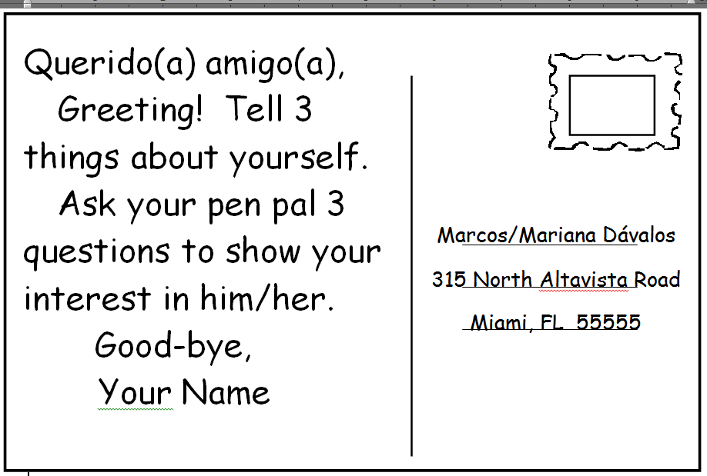
SPANISH THREE: Aug. 19-23 www.srabrown.weebly.com

HOMEWORK GUIDELINES:
= Memorize the spelling and meaning.
= Memorize speaking response by practicing out loud (a min. of 5x)
= TURN IN to la Sra. Brown
La fecha | EN CLASE | LA TAREA / EN CASA
19.8.13 | 1) HW check: comic strips, flashcards, & “Whys” of the INB.  2) Phrase of the Week  3) Famous Latino of the Week  4) Phone a Friend  5) Icebreaker game &/or CERDO | TURN IN if you haven’t yet: a) Soy lo que soy graphic, b) contact sheet/personal info, c) ½ sheet signed syllabus  1) Review the flashcards, especially #1-28, 36-47, 59-78.  1) Review your gustar-type verb notes.
20.8.13 | 1) Review of gustar-type verbs.  2) Review of telling time.  3) Story writing. | 1) Review the flashcards, especially #1-28, 36-47, 59-78.
21.8.13 | 1) Wrap up story writing/editing.  2) Review of –ar/-er/-ir endings.  3) Color verb wall packets. | 1) Copy your story onto INBp ____. Write every other line & write NEATLY. Remember punctuation, capitalization, & spelling.  2) Color AT LEAST three more verb wall packet pages, please. We can’t possibly do it all in class!!!
22.8.13 | MEET IN COMPUTER LAB 210  1) Explore Sra. B’s website  2) Sign up for quia.com’s username & password  3) Start playing EC games  Your INB!!! | Color AT LEAST three more verb wall packet pages, please. We can’t possibly do it all in class!!!
23.8.13 | 1) HOT ticket draw!  2) Review of ser & estar.  3) Continue coloring verb wall packets.  4) Tweet me! | FINISH COLORING the verb wall packet pages, please. We can’t possibly do it all in class!!!

SPANISH FOUR: Aug. 19-23 www.srabrown.weebly.com
HOMEWORK GUIDELINES:
= Memorize the spelling and meaning.
= Memorize speaking response by practicing out loud (a min. of 5x)
= Write each expression 3x each in Spanish and 1x each in English.
= TURN IN to la Sra. Brown
La fecha | EN CLASE | LA TAREA / EN CASA
19.8.13 | Turn in the “Soy lo que soy” graphic & the personal contact info sheet from last week.  1) HW check: “Whys” of the INB  2) Phrase of the Week  3) Famous Latino of the Week  4) Icebreaker/FFO game/CERDO | 1) Download & print the 2nd set of flashcards about how to describe what someone looks like. Review them.
20.8.13 | 1) IN PROGRESS; will be ready by classtime Monday! | 1) ) IN PROGRESS; will be ready by classtime Monday!
21.8.13 | 1) ) IN PROGRESS; will be ready by classtime Monday! | 1) ) IN PROGRESS; will be ready by classtime Monday!
22.8.13 | MEET IN COMPUTER LAB 210  1) Explore Sra. B’s website  2) Sign up for quia.com’s username & password  3) Start playing EC games | 1) ) IN PROGRESS; will be ready by classtime Monday!
23.8.13 | 1) HOT ticket draw!  2) Tweet me! | 1)  ) IN PROGRESS; will be ready by classtime Monday!

